How to tie the elastic (Polar Bear)
Instructions: (see reference image 1, step number relate to the image numbers)
- This hole is for the elastic strap, that holds the mask to the head
- For “articulated jaws”, tie the last two jaw holes to the hole below the elastic strap
- Tie the holes at this location for a “talk jaw”

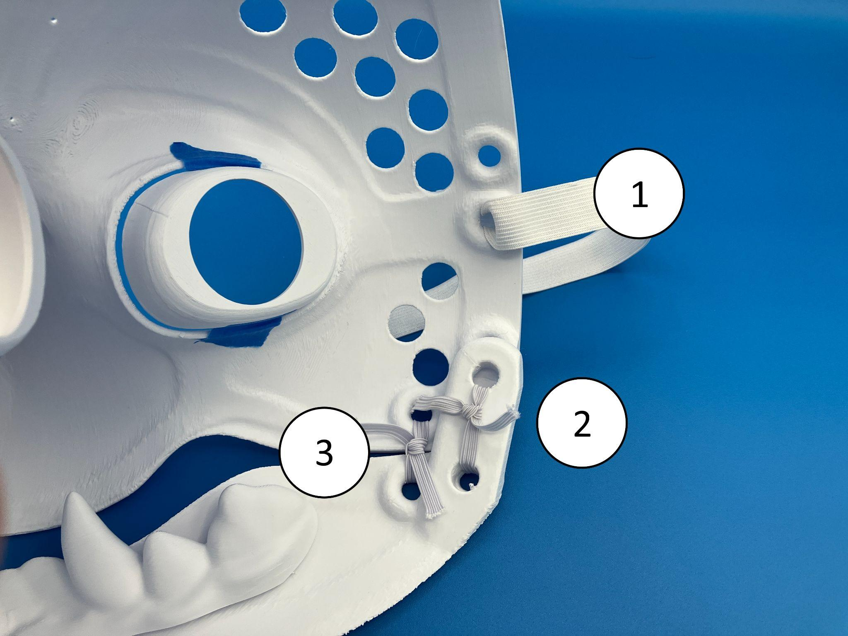
Reference Image 1

If you have issues, please feel free to message me at my etsy shop 3DPrintTherapyShop, or email 3DPrintTherapyShop@gmail.com.

